
Web dEvelopment
Wede5020
Xolani khambule
St10522662
Table of Contents
2. BUSINESS OVERVIEW 2
• Willy’s super cars 2
• History of the organisation 2
• Mission and vision statement 2
• Target audience 2
3. Website Goals and Objectives 3
4. Proposed websites features and functionality 4
WEBSITE FEATURES : 4
Vehicle Listings 4
Search and Categories 4
Contact and Enquiry Forms 4
High-Quality Images 4
Customer Accounts and Communication 4
FUCTIONALITY: 4
5. Design and user experience 5
Colour scheme 5
Typography 5
Layout and design 5
6. Technical requirements 6
7. Timeline and milestone 7
8. Budget 8
9. Reference 9

BUSINESS OVERVIEW

Willy’s super cars
Willy’s super cars is a business where we buy and sell exclusive, vintage and super cars.

History of the organisation
Willy’s Super Cars began as a small dream driven by Xolani Khambule’s passion for rare and powerful cars. He visited car shows and auctions, then started buying, restoring, and selling classic cars. As trust grew, he founded Willy’s Super Cars, focusing on unique vintage and supercars worldwide. Today, the business is known for quality vehicles, trusted service, and helping collectors own extraordinary cars.

Mission and vision statement
Willy’s Super Cars aims to find, restore, and sell rare vintage and high-performance cars to collectors while maintaining high quality, trust, and customer service. Xolani travelled to different countries to find unique cars. He bought a damaged BMW 325 in Soweto for R150,000, restored it, and later sold it for R2,500,000. His vision is to build a globally respected classic car brand.

Target audience
The target audience of Willy’s Super Cars includes wealthy car collectors, luxury car enthusiasts, and businesses looking for rare and high-performance vehicles. These customers appreciate exclusive, vintage, and supercars and are willing to invest in the cars. The business also attracts people who value quality, prestige, and the history behind special cars from around the world.

Website Goals and Objectives
The website goals and objective is to let people know what the business is about and how it operates. It is to increase the profit of the business and show that it is a professional and a legitimate business

Proposed websites features and functionality

WEBSITE FEATURES :

Vehicle Listings
  - Types of vehicles

Search and Categories
  - Searching info and specific car needed

Contact and Enquiry Forms
  - Information about the business

High-Quality Images
  - 360 cam of any vehicle looked at, inside and out.

Customer Accounts and Communication

FUCTIONALITY:
- The correct details of the car, such as the engine size, the year it was made, and the mileage.
- The correct price of the vehicle and clear information about whether it is available or already sold.
- Truthful descriptions of the condition of the car.
- Real contact information and correct details about the business.

Design and user experience

Colour scheme
Black
- Represents luxury and power
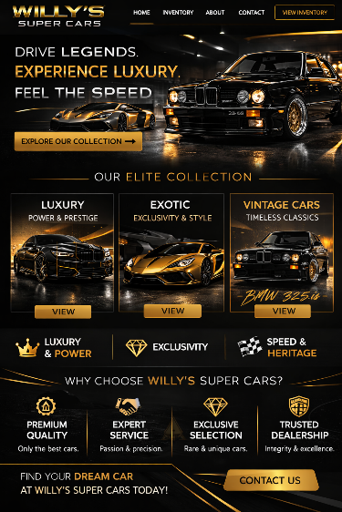
Gold
- Represents exclusivity
Silver
- Represents speed

Typography
It is going to be simple .I’ll be using aptos font text underline a few word and add bold and italics.

Layout and design
- Home
- About us
- Contact us
- Fees and financial accounts
- Shop

Technical requirements
- HTML
- CSS
- JAVA SCRIPS

Timeline and milestone
Launch website and marketing in Month 1–3. Acquire 50–55 vintage cars gradually. Focus on promotions, social media, and local events to generate leads. Sell 6–12 cars monthly. Engage customers with testimonials and email campaigns. Review inventory and sales in Month 8. Goal: 50–55 cars sold successfully.

Budget
Website development (design, content, inventory system) costs R30 000–R40 000. Hosting, domain R3 700–R7 500. Monthly maintenance (updates, backups, security) totals R24 000–R48 000 per year. Total first-year budget: R57 700–R103 500.

Reference
Img.chatgpt,2026.A picture of a super car, luxury car and a vintage car [online].
[ https://chatgpt.com/images ] {access 2026}

